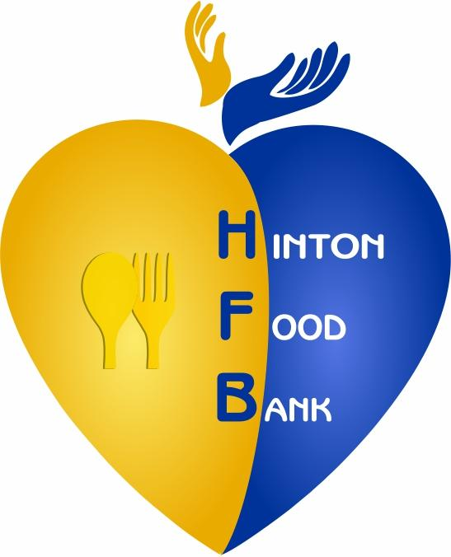 | COMMUNITY  HELPING  COMMUNITY | 
HINTON FOOD BANK ASSOCIATION
11-107 Swanson Drive, Hinton AB T7V 1H1, phone 780-865-6256
hintonfoodbank@gmail.com
The Hinton Food Bank believes in “community serving community”. We promote respect and dignity when serving our clients.

Approximately 5% of residents in our community rely on the food bank to help meet their needs, either on an ongoing or temporary basis. Our clients have incomes that do not cover basic living costs. Unfortunately, food banks are needed to bridge this gap.

Description | Adults served | Children served | Family units served | New family units | Total people served
ACTUAL-2016 | 4148 | 2170 | 2204 | 193 | 6318
ACTUAL-2017 | 4572 | 2243 | 2568 | 114 | 6815
ACTUAL-2018 | 4260 | 2228 | 2394 | 123 | 6488
ACTUAL-2019 | 4428 | 2289 | 2539 | 130 | 6717
ACTUAL-2020## | 4665 | 2336 | 2892 | 188 | 7001
ACTUAL 2021 | 4926 | 2082 | 2898 |  | 7008
ACTUAL 2022 | 5499 | 2155 | 3682 |  | 7654
ACTUAL 2023 | 7026 | 3153 | 4615 |  | 10174
AVERAGE/WEEK in 2023 | 138 | 62 | 90.5 |  | 200
AVERAGE/WEEK in 2022 | 106 | 41.5 | 71 |  | 147
The Hinton Food Bank provided food to an average of 90 family units/week in 2023 which represents a weekly average of 200 people assisted.

## Due to COVID-19 etc., 2020 was an extraordinary year for Hinton Food Bank demand. Very busy March to May and again from Oct. to Dec, but below normal when SERB was available. Also, there were also two periods (April-June and Dec) when hamper delivery service was offered.

Bernie Kreiner-Chairperson of Hinton Food Bank Board. Call/text to 7808659355

